OS LAB 1

NAME: Aditya Anand

ROLL NO.: 20124009

BRANCH: IT

**BASIC LINUX COMMANDS**

1. pwd : prints the name of the current working directory

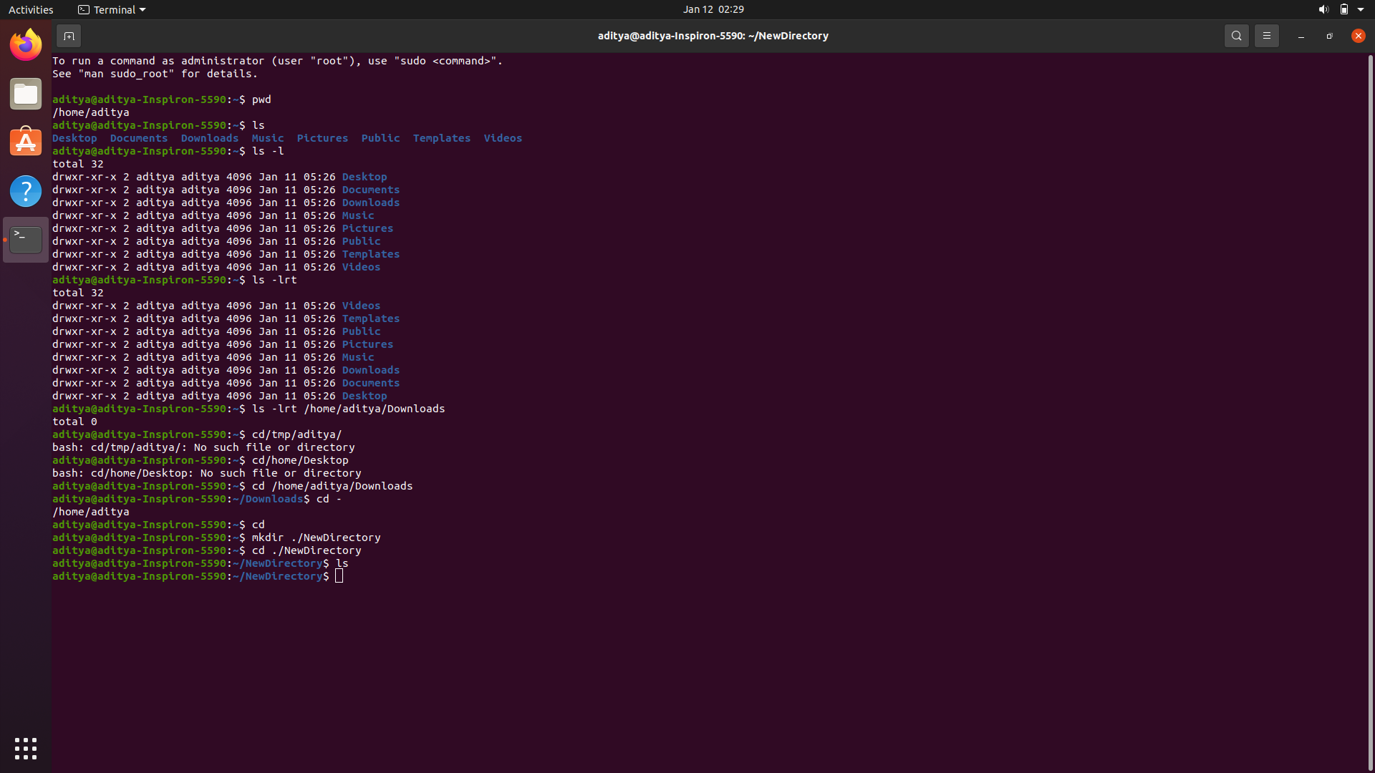

1. ls : list contents of the current working directory

ls -lrt : long listing

ls -lrt /home/name/something : long list a different directory



1. cd : change directory



1. mkdir : create a new directory



1. man : display the manual of a given program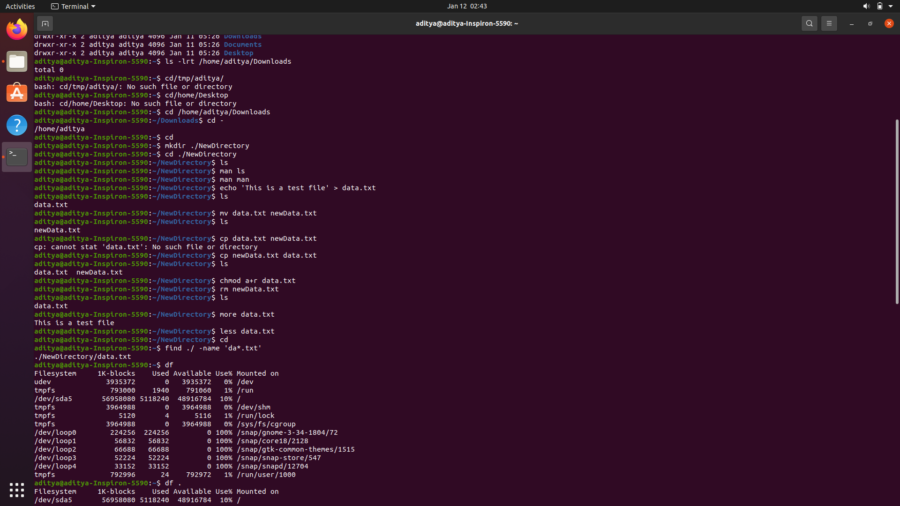

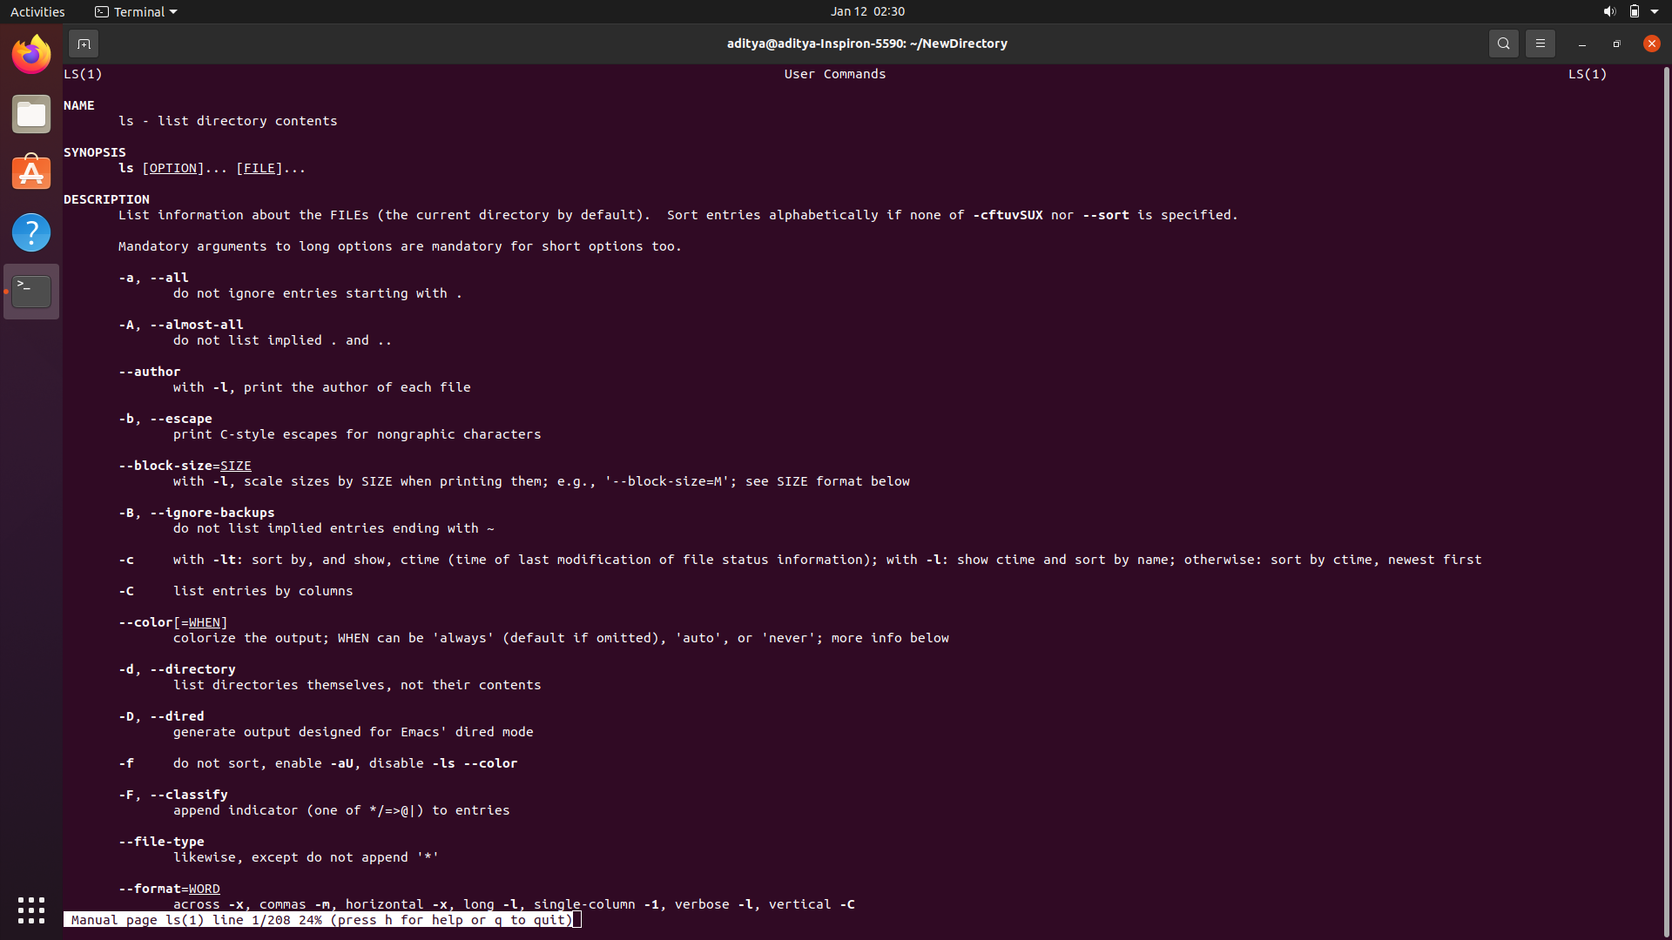

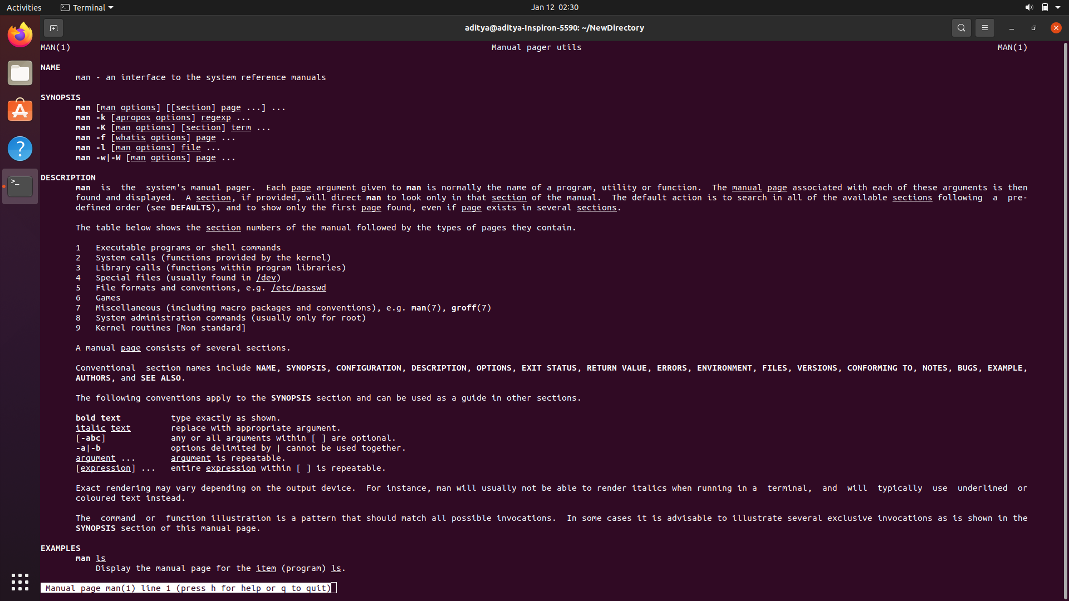

1. echo : to create a file

SYNTAX: echo ‘Text to be added’ > filename



1. mv : move or rename a file



1. cp : copy a file



1. chmod : change the permissions of a file



1. rm : delete a file forever



1. more : displays the contents of a file page by page

less : a replacement for more, displays data more nicely and makes search easy



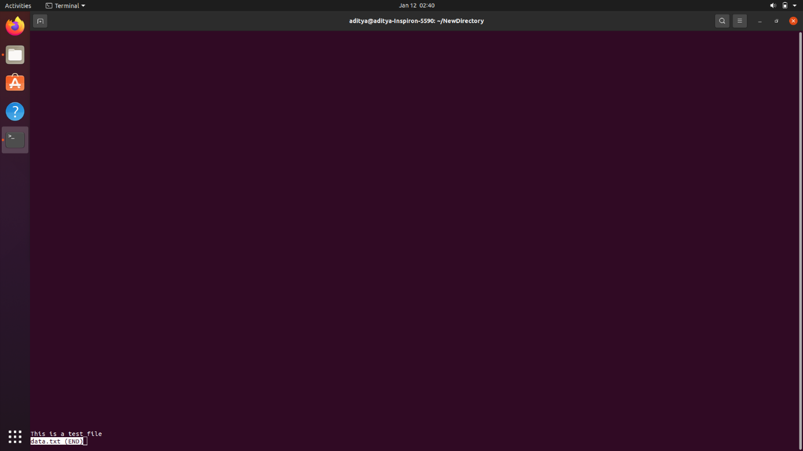

1. find : search for files across directories



1. df : check how much space is left



1. top : list processes in order of CPU storage

